Razvoj novog modela - transformacija sedd i dist - Rattle

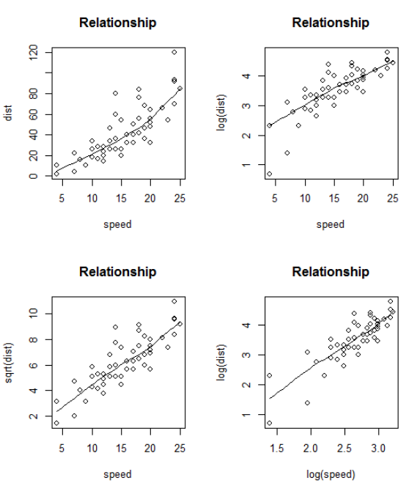

**Prvi model : dist~speed**

Summary of the Linear Regression model (built using lm):

Residuals:

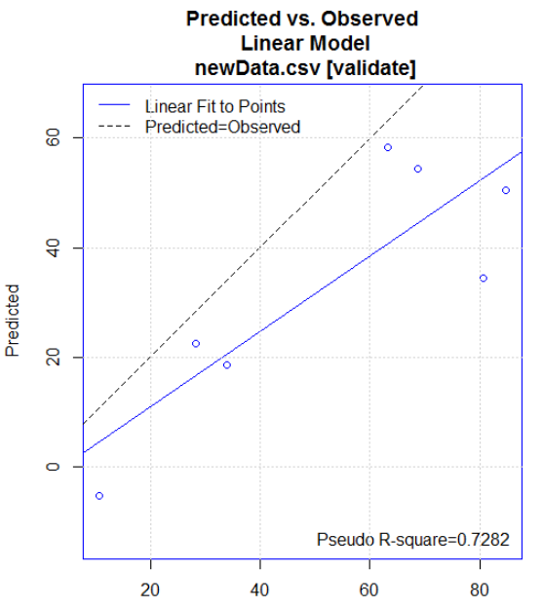 Min 1Q Median 3Q Max

-18.47 -6.48 -2.44 4.46 45.79

Coefficients:

Estimate Std. Error t value Pr(>|t|)

(Intercept) -21.097 6.776 -3.11 0.0038 **

speed 3.971 0.418 9.49 5.9e-11 ***

---

Signif. codes: 0 '***' 0.001 '**' 0.01 '*' 0.05 '.' 0.1 ' ' 1

Residual standard error: 12.9 on 33 degrees of freedom

Multiple R-squared: 0.732, Adjusted R-squared: 0.724

F-statistic: 90.1 on 1 and 33 DF, p-value: 5.86e-11

==== ANOVA ====

Analysis of Variance Table

Response: dist

Df Sum Sq Mean Sq F value Pr(>F)

speed 1 14915 14915 90.1 5.9e-11 ***

Residuals 33 5462 166

---

Signif. codes: 0 '***' 0.001 '**' 0.01 '*' 0.05 '.' 0.1 ' ' 1

[1] "\n"

Time taken: 0.02 secs

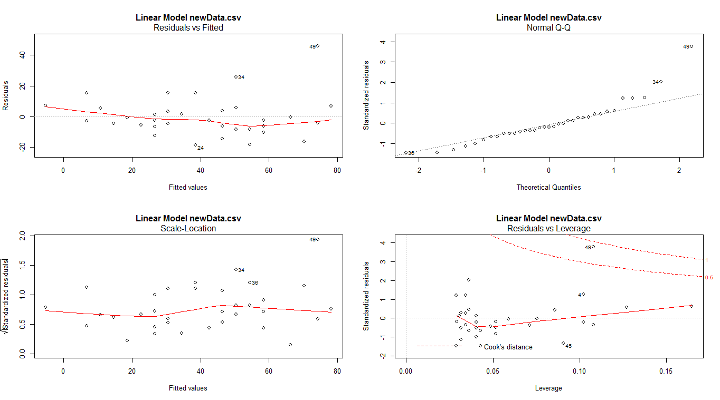Rattle timestamp: 2018-02-01 01:20:26 admin

**Sqrt(dist)~speed**

Summary of the Linear Regression model (built using lm):

Residuals:

Min 1Q Median 3Q Max

-1.409 -0.597 -0.106 0.499 2.034

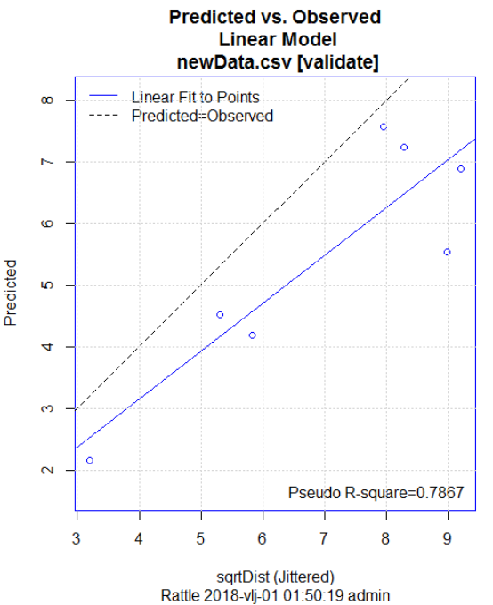Coefficients:

Estimate Std. Error t value Pr(>|t|)

(Intercept) 0.8150 0.4816 1.69 0.1

speed 0.3377 0.0297 11.36 6.1e-13 ***

---

Signif. codes: 0 '***' 0.001 '**' 0.01 '*' 0.05 '.' 0.1 ' ' 1

Residual standard error: 0.914 on 33 degrees of freedom

Multiple R-squared: 0.796, Adjusted R-squared: 0.79

F-statistic: 129 on 1 and 33 DF, p-value: 6.05e-13

==== ANOVA ====

Analysis of Variance Table

Response: sqrtDist

Df Sum Sq Mean Sq F value Pr(>F)

speed 1 107.9 107.9 129 6.1e-13 ***

Residuals 33 27.6 0.8

---

Signif. codes: 0 '***' 0.001 '**' 0.01 '*' 0.05 '.' 0.1 ' ' 1

[1] "\n"

Time taken: 0.02 secs

Rattle timestamp: 2018-02-01 00:51:46 admin

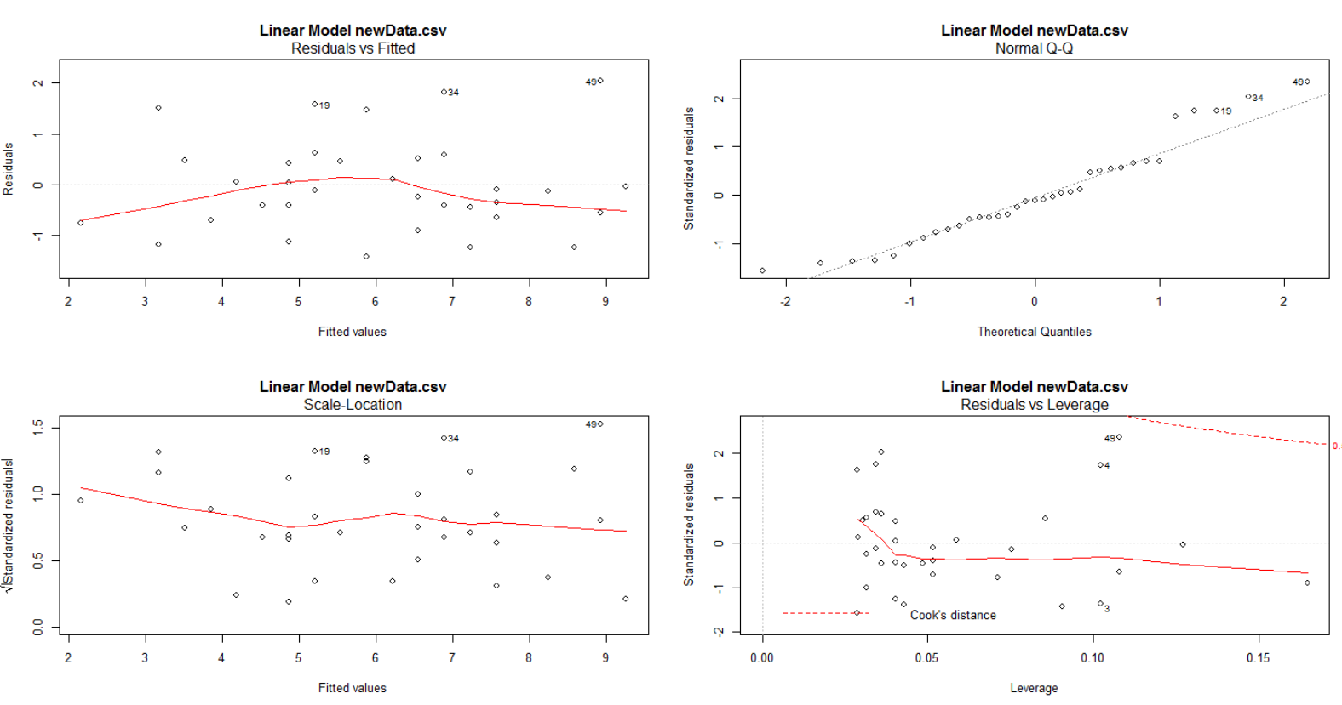

**log(dist)~log(speed)**

Summary of the Linear Regression model (built using lm):

Residuals:

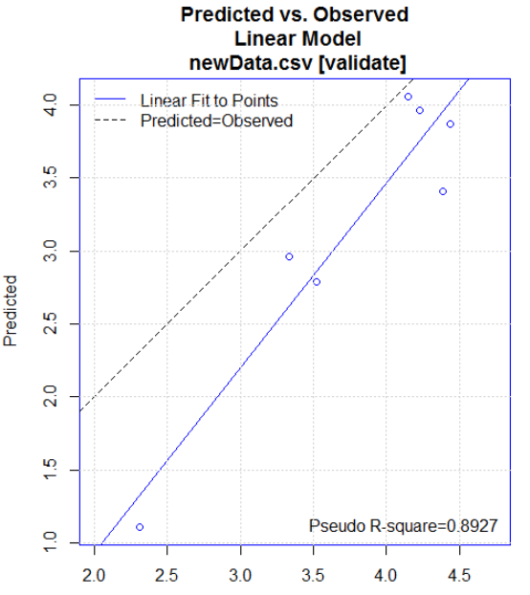 Min 1Q Median 3Q Max

-0.748 -0.167 -0.034 0.194 0.957

Coefficients:

Estimate Std. Error t value Pr(>|t|)

(Intercept) -1.433 0.400 -3.59 0.0011 **

logSpeed 1.833 0.148 12.35 6.4e-14 ***

---

Signif. codes: 0 '***' 0.001 '**' 0.01 '*' 0.05 '.' 0.1 ' ' 1

Residual standard error: 0.351 on 33 degrees of freedom

Multiple R-squared: 0.822, Adjusted R-squared: 0.817

F-statistic: 152 on 1 and 33 DF, p-value: 6.44e-14

==== ANOVA ====

Analysis of Variance Table

Response: logDist

Df Sum Sq Mean Sq F value Pr(>F)

logSpeed 1 18.74 18.74 152 6.4e-14 ***

Residuals 33 4.06 0.12

---

Signif. codes: 0 '***' 0.001 '**' 0.01 '*' 0.05 '.' 0.1 ' ' 1

[1] "\n"

Time taken: 0.02 secs

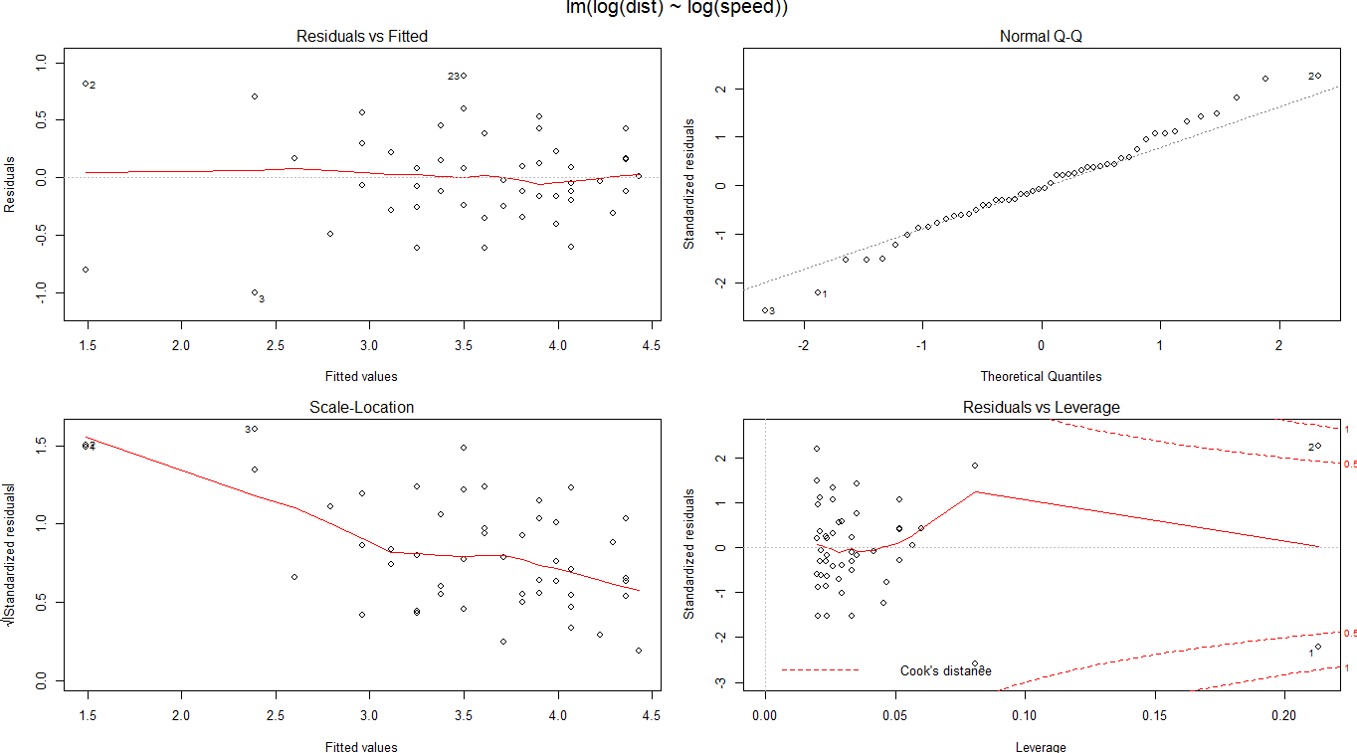**Izvor : https://stat.ethz.ch/R-manual/R-devel/library/datasets/html/cars.html**

**dist~speed^2**

Summary of the Linear Regression model (built using lm):

Residuals:

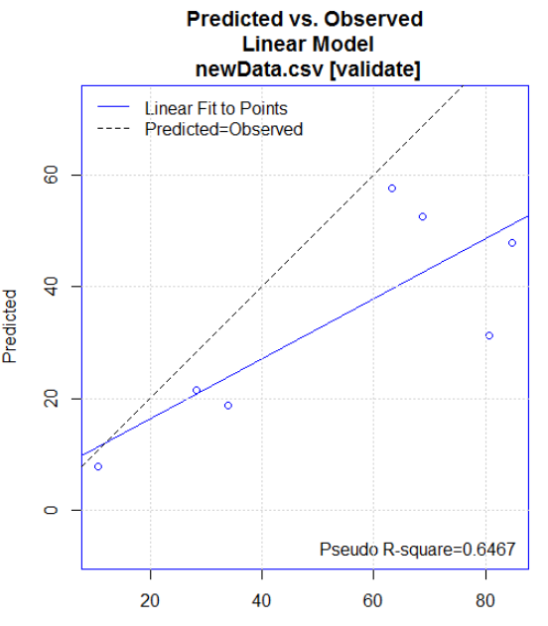 Min 1Q Median 3Q Max

-20.48 -6.44 -1.96 5.56 39.41

Coefficients:

Estimate Std. Error t value Pr(>|t|)

(Intercept) 5.714 4.001 1.43 0.16

powSpeed 0.130 0.013 10.00 1.6e-11 ***

---

Signif. codes: 0 '***' 0.001 '**' 0.01 '*' 0.05 '.' 0.1 ' ' 1

Residual standard error: 12.4 on 33 degrees of freedom

Multiple R-squared: 0.752, Adjusted R-squared: 0.744

F-statistic: 100 on 1 and 33 DF, p-value: 1.61e-11

==== ANOVA ====

Analysis of Variance Table

Response: dist

Df Sum Sq Mean Sq F value Pr(>F)

powSpeed 1 15323 15323 100 1.6e-11 ***

Residuals 33 5054 153

---

Signif. codes: 0 '***' 0.001 '**' 0.01 '*' 0.05 '.' 0.1 ' ' 1

[1] "\n"

Time taken: 0.03 secs

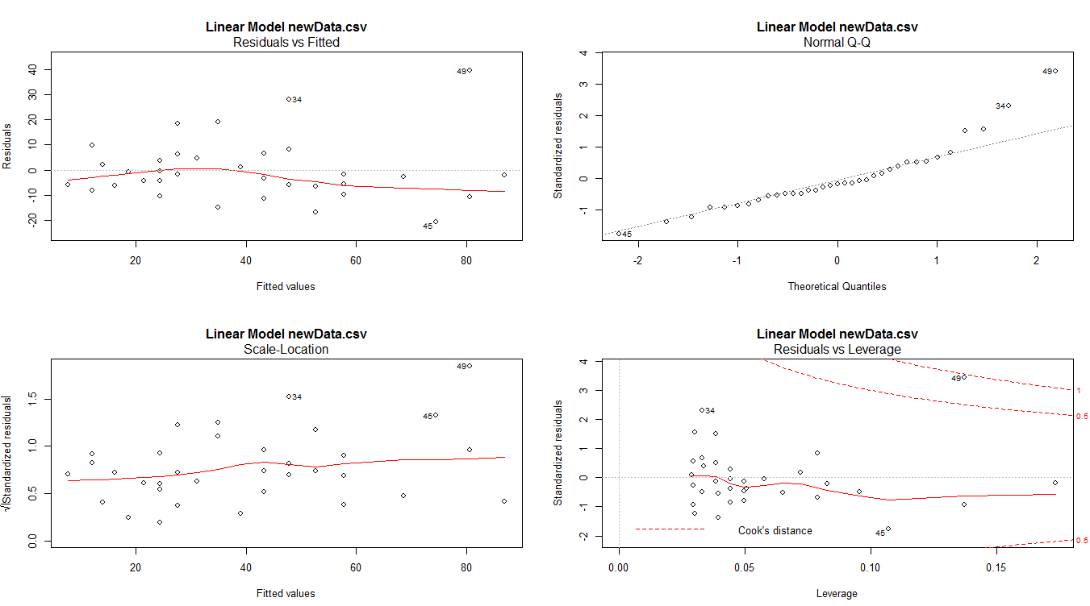Rattle timestamp: 2018-02-01 02:27:16 admin

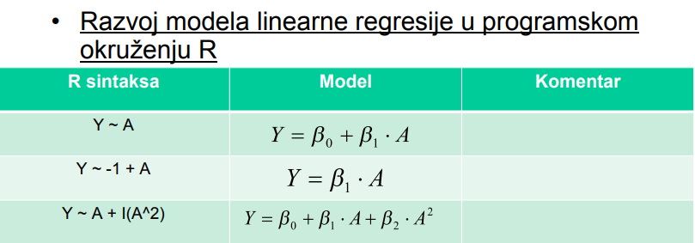

> y = lm(formula = dist ~ (-1+speed), data=cars)

>

> summary(y)

Call:

**lm(formula = dist ~ (-1 + speed), data = cars)**

Residuals:

Min 1Q Median 3Q Max

-26.18 -12.64 -5.46 4.59 50.18

Coefficients:

Estimate Std. Error t value Pr(>|t|)

speed 2.909 0.141 20.6 <2e-16 ***

---

Signif. codes: 0 ‘***’ 0.001 ‘**’ 0.01 ‘*’ 0.05 ‘.’ 0.1 ‘ ’ 1

Residual standard error: 16.3 on 49 degrees of freedom

Multiple R-squared: 0.896, Adjusted R-squared: 0.894

F-statistic: 423 on 1 and 49 DF, p-value: <2e-16

> anova(y)

Analysis of Variance Table

Response: dist

Df Sum Sq Mean Sq F value Pr(>F)

speed 1 111949 111949 423 <2e-16 ***

Residuals 49 12954 264

---

Signif. codes: 0 ‘***’ 0.001 ‘**’ 0.01 ‘*’ 0.05 ‘.’ 0.1 ‘ ’ 1

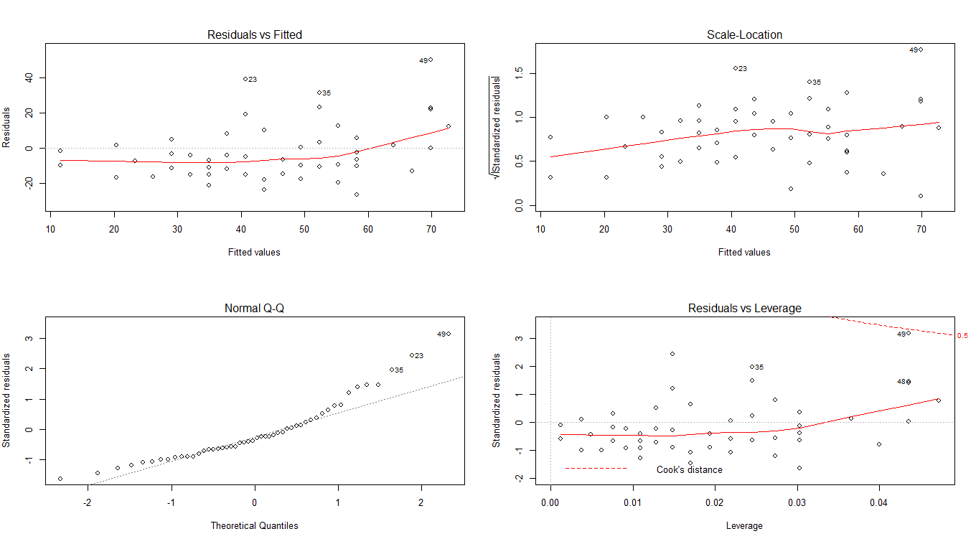

> y = lm(formula = dist ~ (1+speed), data=cars)

> summary(y)

Call:

**lm(formula = dist ~ (1 + speed), data = cars)**

Residuals:

Min 1Q Median 3Q Max

-29.07 -9.53 -2.27 9.21 43.20

Coefficients:

Estimate Std. Error t value Pr(>|t|)

(Intercept) -17.579 6.758 -2.60 0.012 *

speed 3.932 0.416 9.46 1.5e-12 ***

---

Signif. codes: 0 ‘***’ 0.001 ‘**’ 0.01 ‘*’ 0.05 ‘.’ 0.1 ‘ ’ 1

Residual standard error: 15.4 on 48 degrees of freedom

Multiple R-squared: 0.651, Adjusted R-squared: 0.644

F-statistic: 89.6 on 1 and 48 DF, p-value: 1.49e-12

> anova(y)

Analysis of Variance Table

Response: dist

Df Sum Sq Mean Sq F value Pr(>F)

speed 1 21185 21185 89.6 1.5e-12 ***

Residuals 48 11354 237

---

Signif. codes: 0 ‘***’ 0.001 ‘**’ 0.01 ‘*’ 0.05 ‘.’ 0.1 ‘ ’ 1

> layout(matrix(1:4,2,2))

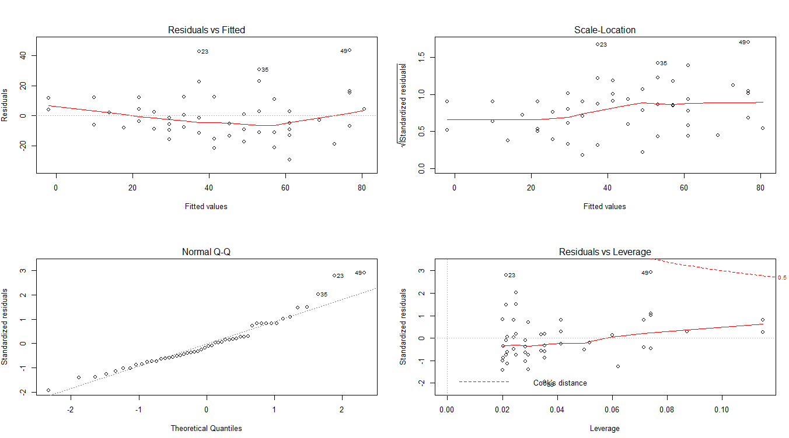> plot(y)

> y = lm(formula = dist ~ (speed+speed^2), data=cars)

> summary(y)

Call:

**lm(formula = dist ~ (speed + speed^2), data = cars)**

Residuals:

Min 1Q Median 3Q Max

-29.07 -9.53 -2.27 9.21 43.20

Coefficients:

Estimate Std. Error t value Pr(>|t|)

(Intercept) -17.579 6.758 -2.60 0.012 *

speed 3.932 0.416 9.46 1.5e-12 ***

---

Signif. codes: 0 ‘***’ 0.001 ‘**’ 0.01 ‘*’ 0.05 ‘.’ 0.1 ‘ ’ 1

Residual standard error: 15.4 on 48 degrees of freedom

Multiple R-squared: 0.651, Adjusted R-squared: 0.644

F-statistic: 89.6 on 1 and 48 DF, p-value: 1.49e-12

> anova(y)

Analysis of Variance Table

Response: dist

Df Sum Sq Mean Sq F value Pr(>F)

speed 1 21185 21185 89.6 1.5e-12 ***

Residuals 48 11354 237

---

Signif. codes: 0 ‘***’ 0.001 ‘**’ 0.01 ‘*’ 0.05 ‘.’ 0.1 ‘ ’ 1

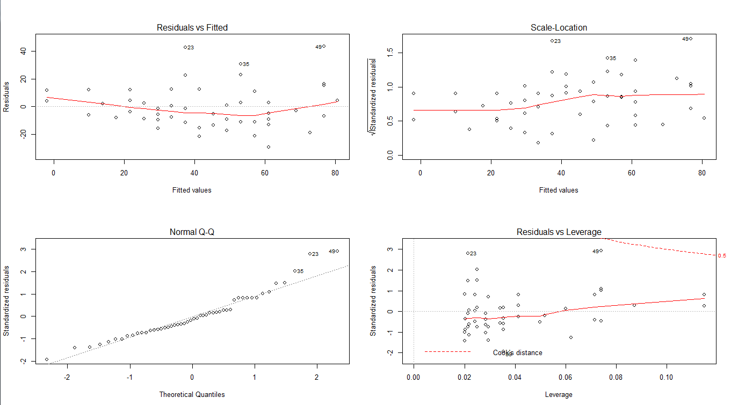> layout(matrix(1:4,2,2))

> plot(y)

**y = lm(formula = dist ~ (-1+speed), data=cars)** *dobar na cijeloj bazi ^^*

set.seed(100)

trainingRowIndex = sample(1:nrow(cars), 0.8*nrow(cars))

trainingdata = cars[trainingRowIndex, ]

testData = cars[-trainingRowIndex, ]

> y = lm(formula = dist ~ (-1+speed), data=trainingdata)

> summary(y)

Call:

lm(formula = dist ~ (-1 + speed), data = trainingdata)

Residuals:

Min 1Q Median 3Q Max

-25.09 -15.37 -7.07 4.68 47.85

Coefficients:

Estimate Std. Error t value Pr(>|t|)

speed 3.006 0.166 18.1 <2e-16 ***

---

Signif. codes: 0 ‘***’ 0.001 ‘**’ 0.01 ‘*’ 0.05 ‘.’ 0.1 ‘ ’ 1

Residual standard error: 17.2 on 39 degrees of freedom

Multiple R-squared: 0.894, Adjusted R-squared: 0.891

F-statistic: 330 on 1 and 39 DF, p-value: <2e-16

> anova(y)

Analysis of Variance Table

Response: dist

Df Sum Sq Mean Sq F value Pr(>F)

speed 1 97524 97524 330 <2e-16 ***

Residuals 39 11543 296

---

Signif. codes: 0 ‘***’ 0.001 ‘**’ 0.01 ‘*’ 0.05 ‘.’ 0.1 ‘ ’ 1

> layout(matrix(1:4,2,2))

> plot(y)

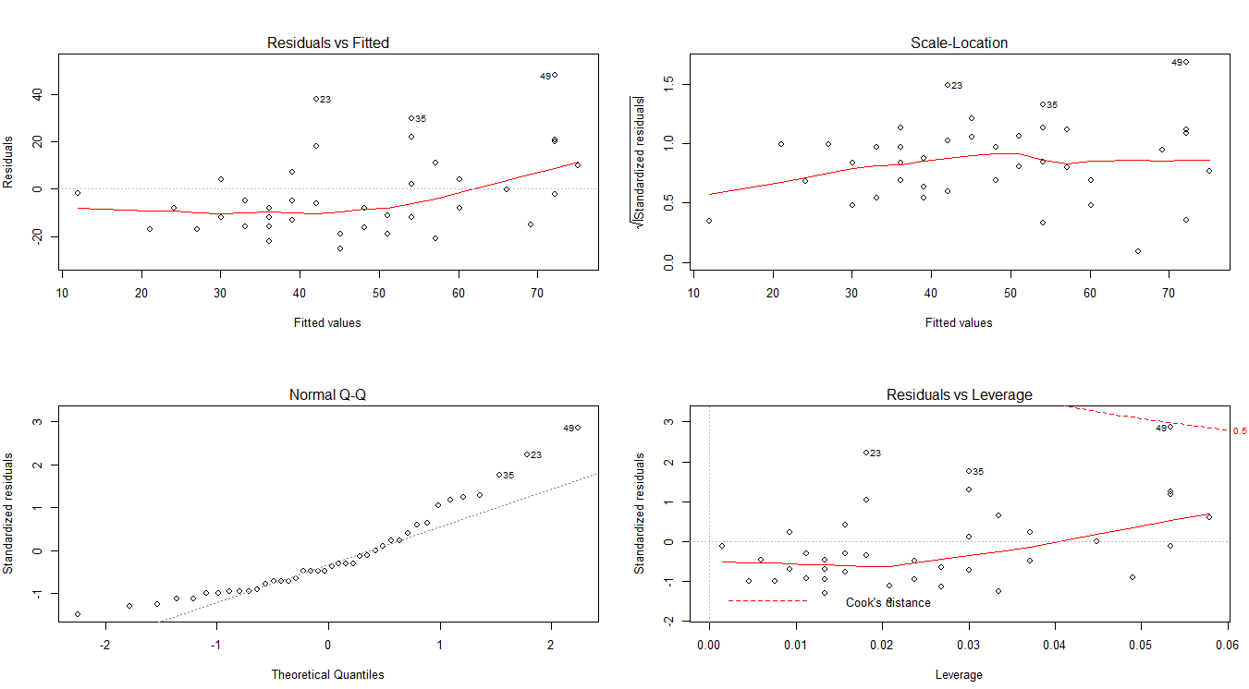***dobar na train podacima***